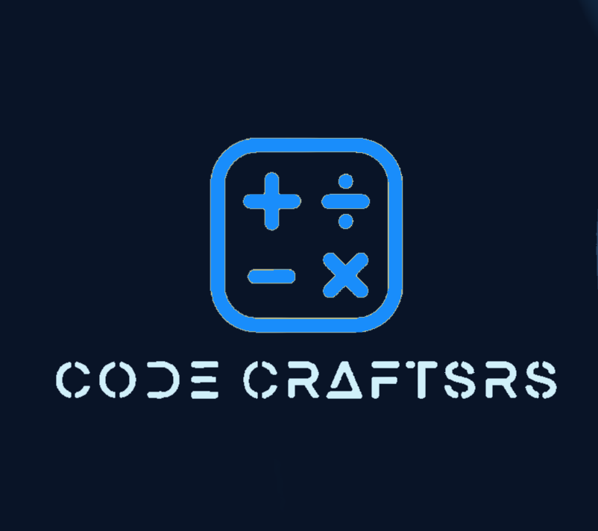

Table of Contents

Team 3

Introduction 4

Implementation 4

# Team

Scrum trainer

Nia Georgieva Georgieva

Front-End Developer

Alexandur Vladislavov Georgiev

Front-End Developer

Anastas Vasilev Apostolov

Designer

Mila Krasimirova Lazarova

## Introduction

Welcome to Code Crafters. This project’s idea is to make a website that introduces people to Fibonacci and to show the connection between math and nature.

## Implementation

* Communication

For our communication we mainly used Teams.

* Program Applications

We used Visual Studio Code to code our website. For the documentation we depended on Word and for our presentation we used PowerPoint